Welcome to Grade11 IB Students

Monday October 5, 2020

Welcome to Saint John Paul II and the International Baccalaureate Diploma Programme. As grade 11 students, you are in what IB refers to as your “anticipated year”. This year you will be working your way through the requirements of your IB streams, culminating with the SL French B exams! Here is some information to help you and your parents get acquainted with the programme.
Please note: if you are only take some courses at the IB level in “bundles” only the information pertaining to those courses are relevant to you.

IB Courses:
As a reminder, throughout this year, you should have 8 courses total (2 per “quadmester”) and all of these courses are at the IB level. All students will be taking the following courses:
- Grade 11 English ENG3U5 and Grade 12 English EWC4U5
- Grade 11 French FSF3U4 and Grade 12 French FSF4U4
- Grade 12 Math MHF4U4
- And the rest of your courses are dependent on your stream which will include some of the following: Business Management, History of the Americas, Biology, Chemistry, Physics, Visual Arts, Music.
- If you are taking a course at the Higher Level (3 maximum), they will end with a “5”
- If you are taking a course at the Standard Level (3 maximum), they will end with a “4”
- The IB CORE - Theory of Knowledge, Creativity Activity and Service and Extended Essay will be introduced throughout the year
- More details on each of these things to follow

Communication:
We need to establish some lines of communication. We use www.edmodo.com as our free, online platform to communicate with both JP and IB students and their parents. I will send notices about newsletters, events, activities, volunteer opportunities and good news stories about IB.Please take some time to go to www.edmodo.com and verify that your account from last year is still there. If you never made an account, IT IS IMPERATIVE THAT YOU MAKE ONE as this is the easiest way to communicate with you and your parents.

I have attached two information documents - one for students and one for parents, outlining how to sign up for a free account.
- Student Sign Up Edmodo
- Find a student’s parent code edmodo

Please let me know if you have any questions or difficulties in creating your account.
ManageBac:
All grade 11 students have an account on our IB platform management system, ManageBac. Students will be able to track and upload materials for the IB Core, TOK, EE and CAS. It will also be a way for student to communicate with their EE supervisors and for the IB Coordinator and EE/CAS Coordinator to post messages regarding all things IB - volunteer opportunities, IB materials, dates, and activities. If you have any questions about this system, please speak with Ms. Regimbal who is the manager of our site. We pay for these accounts,so please make use of them. They are a time saver.

IB Fees
Due to the school closure last year due to Covid-19, we did not collect a partial payment for Grade 11 IB students as we normally do. Therefore, the full amount, of $400.00 is due this year for Grade 11 Students. This covers your registration and IB French exam fees.

All payments this year will be done through school cash online. Attached to this welcome package is a written explanation of how to set up your account. You will notice that you can pay in installments - with the amounts of $50, $100 or the full amount of $400.

Some amount must be paid by October 31, 2020 in order for me to register you for IB this year. IB registration must be completed by November 15, 2020 and no student is registered unless they have contributed something (does not need to be the full amount).

Any family who has concerns about this should speak with Mr. Wetzel, the Principal.

Additional Materials:
Introducing SJP II IB Website!
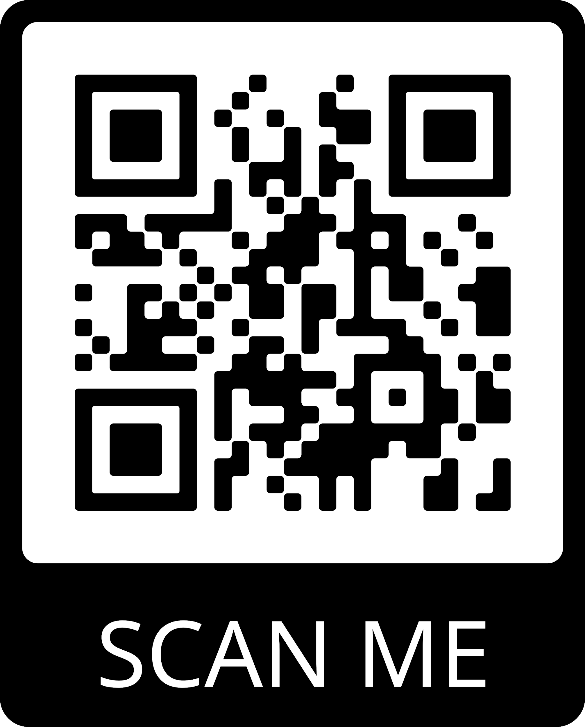
CAS Legacy project by Allison Oldfield, IB Grad 2019, currently supervised by Ann Marie Parrenas, IB Class 2022.
Link: St John Paul II IB Programe (ibstjohnpaulii.com)
Annual Note to Grade 11 IB students – Stay tuned for when we look for one volunteer to work on maintaining this website under the guidance of the current website manager. The expectation would be that you would take on the responsibilities of supervision in Grade 12 and would train a Grade 11 student and so on. In this way, our legacy project that start in 2019 will continue to grow!

Link to Grade level assemblies - Grade11
https://drive.google.com/file/d/1vlF_qPBe5t2edy1CMCOxQDmL2ggdv62u/view?usp=sharing

Link to a list of materials every IB Student should have (created by IB graduating class 2020)
IB_HANDBOOK___List_of_materials_every_IB_student_should_have

Link to tips every IB student should know before completing the IB program (created by IB graduating class 2020)
https://drive.google.com/file/d/1mtQOQQntWD29Xsj2VC2PZDbImH6kdu3u/view?usp=sharing

Link to a video testimonial from an IB grad, 2020, on the benefits of IB
https://drive.google.com/file/d/1lVXOXdz0YgI_ofCIjg35FxsqkIT1diYw/view?usp=sharing

Links to support materials on approaching teachers (created by the IB graduating class of 2020)
https://drive.google.com/file/d/1bb4_ti_s7v2xytGVDHCCKL2032LuswEo/view?usp=sharing

Links to support materials on time management (created by the IB graduating class of 2020)
https://drive.google.com/file/d/17-D_M8RTcgTw-bFaBU_5eTMn-_c_0A9L/view?usp=sharing

Links to support materials on stress management (created by the IB graduating class of 2020)
https://drive.google.com/file/d/1d396zBn_dvF1xu46CKlhyValLnUgsS7V/view?usp=sharing

Links to support materials on the benefits of IB (created by the IB graduating class of 2020)
https://drive.google.com/file/d/1DxtrjTPK9XWx01WA056ULZGd1TWq_BIM/view?usp=sharing

The How-Tos of OPCVL for History
https://docs.google.com/document/d/1VgF3Hio7gwulzKcX18CvIcKbeb8NBjp3Rj7LkXCrJQc/edit?usp=sharing

The No-Nos of IB
https://docs.google.com/document/d/1mVM-qnAXPFE2Ap6UdIx7RTf91ngTNMuuwWbQV9332JA/edit?usp=sharing

English SCASI Notes
https://docs.google.com/document/d/1SS4ejE-LJkAFPm8KjFC8frsMJRU6w1kKpo9GF1VnfNI/edit?usp=sharing

Table of Equivalents
https://docs.google.com/document/d/1HrqxAwM9mxDZB5Iqlcsed-lztqq3lSj8HbpPsiiZcJ4/edit?usp=sharing

Tips for IB French
https://dochub.com/robertt-z9nniz/DL7JlEGV1NMaepawrWe0oa/tips-for-french?dt=ZbUz7vspBa9M9T86KDpH

Helpful Online Resources for IB
https://drive.google.com/file/d/181L7v9Jen7ot0v2Iyo7hXxEyoAqTQ9Se/view?usp=sharing

Academic Honesty Pamphlet
https://dochub.com/robertt-z9nniz/YpDBonNVrxov7NYRMX93r7/copy-of-copy-of-academic-honesty-pamphlet-pdf?dt=Bt7HuivG1DkFTyTF8z8p

School Cash Online
https://drive.google.com/file/d/1lvfG-7GjbI01jdE4sGk6iaRAhDFoo-us/view?usp=sharing

I look forward to meeting you (eventually) in person or virtually throughout this year. I would like to wish everyone a healthy, happy and successful quadmester. I currently teach two courses but am available for phone or video conferencing if you have any questions. I also respond quite quickly via email. Please get in touch with me at tracey.robertson@tcdsb.org or call the school at 416 393 5531 to leave a message with the secretaries for me and I will respond as quickly as I can to your inquiries.

Sincerely,
Tracey Robertson
IB DP Coordinator
CWS Department Head

