Find a Student's Parent Code
Every student has a unique Parent Code. This code is used to create a Parent account, and links the parent to the student. By associating with a student, the Parent account is automatically populated with information from all Groups that their student has joined. If a parent has multiple students using Edmodo, they should obtain the Parent Code for each student and then add a student once logged in to their existing account.
The Parent Code for an individual student can be found by the Teacher, or within the Student account.
- Log-in to the Student account on the web.
- Log-in to the Student account on the iPhone or iPad app.
- Log-in to the Student account on the Android app.
- Ask the Teacher for the Student's Parent code.
A Parent or Student can find the Student's Parent Code by logging in to the Student's account on the web:
- Logging in to the student's account.
- Scrolling down and finding the Parent Code on the bottom left corner of the home page.
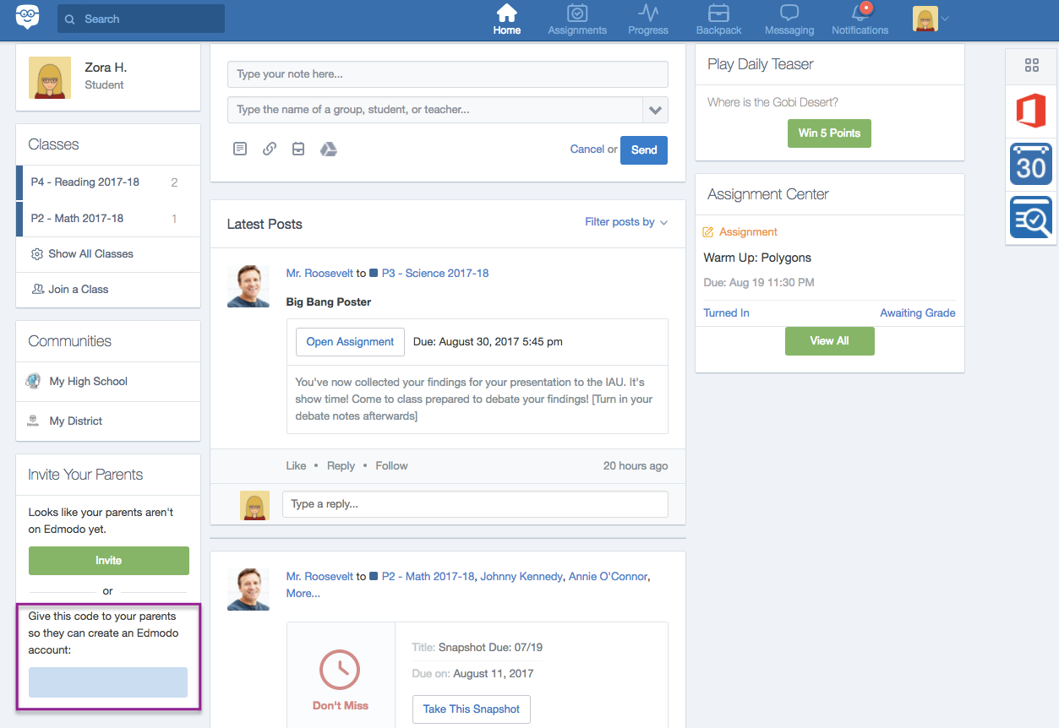

Find the Student's Parent code in their account on the iPhone or iPad app by:
- Logging into the Student iOS app.
- Tapping More on the bottom navigation menu.
- Tapping the Student's name at the top.
- The Parent code is in blue font below the blue "Invite Parent" button
Find the Student's Parent code in their account on the Android app by:
- Logging into the Student Android app.
- Tapping More on the bottom navigation menu.
- Selecting "My Profile."
- The Parent code is in blue font below the blue "Invite Parent" button
The Teacher can locate an Student's Parent code by:
- Selecting the Class/Group from the left side panel of the home page.
- Clicking the “Members” tab from the left side panel.
- Clicking the three horizontal dots next to a student's name.
- Clicking "Parent Code" and the student's Parent Code will pop up.

